# RECRUITMENT MANAGEMENT

Use this module to carry out the entire recruitment process i.e. from publishing a job, receiving applications, filtering applicants and going through the entire selection process up to hiring. This section has 6 parts such as;

* Manage jobs
* Add new jobs
* Candidates
* Careers page
* Recruitment Pipeline Stages
* Recruitment Progress Report
* Candidates biodata report

The figure below shows where to find the recruitment module by clicking Modules -> Recruitment

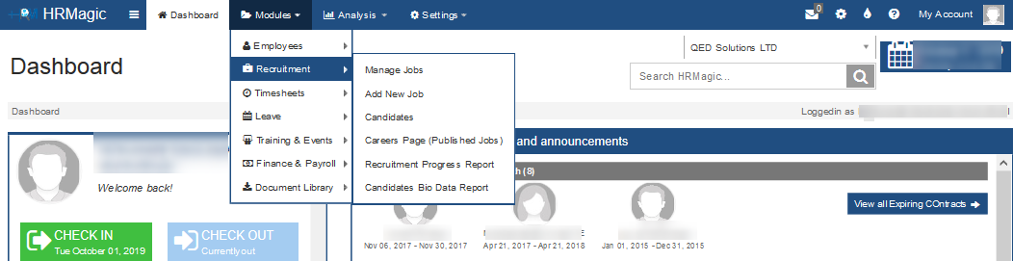

Figure 1: Recruitment Module

## Manage jobs

The Admin/HR with the rights can view and manage all job details from this interface.To navigate to this section, go to **Module -> Recruitment -> Manage jobs.**

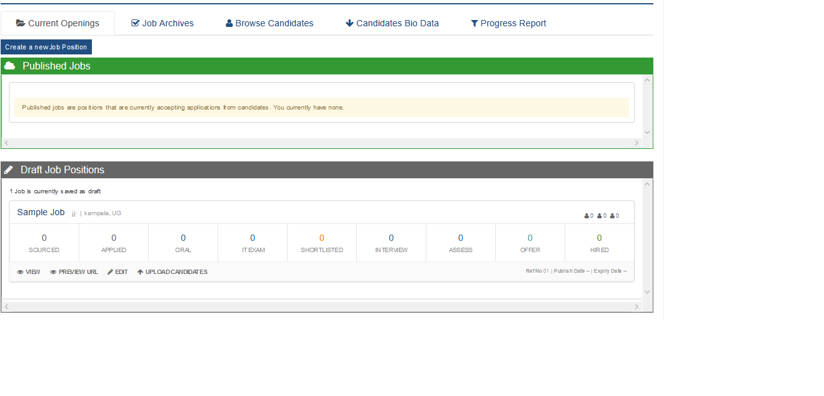

Figure 2: Manage Jobs

## Add new job

To access this section, an employee can use the above interface in figure 2 and click on the Create New Job position tab as shown below.



Or go to **Module -> Recruitment -> Add new job**. This section is where the job position is created and it’s in 5 steps. Just follow the wizard up to the end.

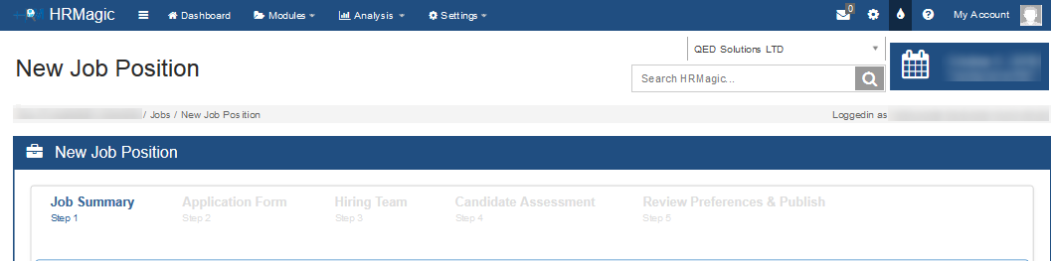

Figure 3: New Job

**NOTE**: Each step of the registration process must be filled to proceed to the next steps.

### Job Summary

This is step 1 of the new job registration. Under this section, the HR fills in all the required fields such as job position, department, job responsibility, job specifications, requirements and many more.

### Application Form

Under this section, the HR sets the outlay of the application form by clicking on the desired checkbox provided. The preview of this form is seen on the left side of the screen. Save as draft or save and proceed to the next step.

### Hiring Team

This is the team in-charge of the recruitment process of a particular job. This section has 2 options; existing system user and new user. If the HR selects an existing system user, a drop-down from the system is availed for selection of the team member. When the new user is selected, the fields such as names, email, and roles are filled.

After selecting the right option and filling in the required information, click the send invitation tab as shown below. After which email notifications shall be sent to their emails.

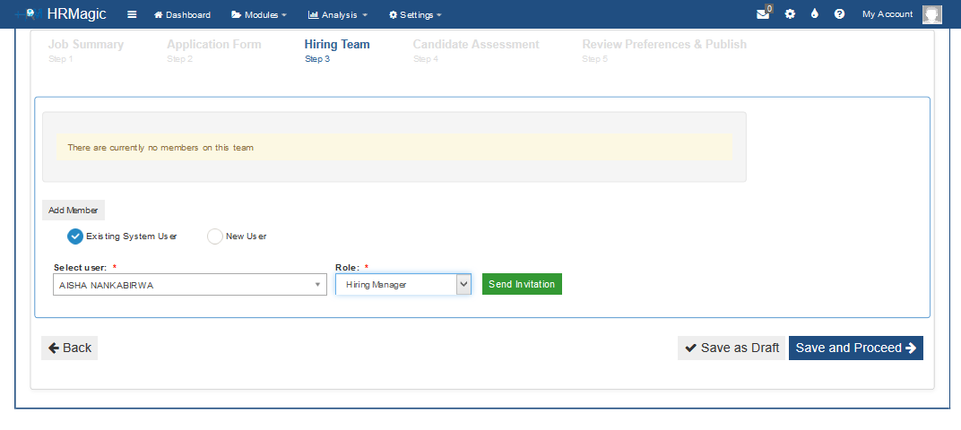

The figure below shows an email notification sent to a selected team member.

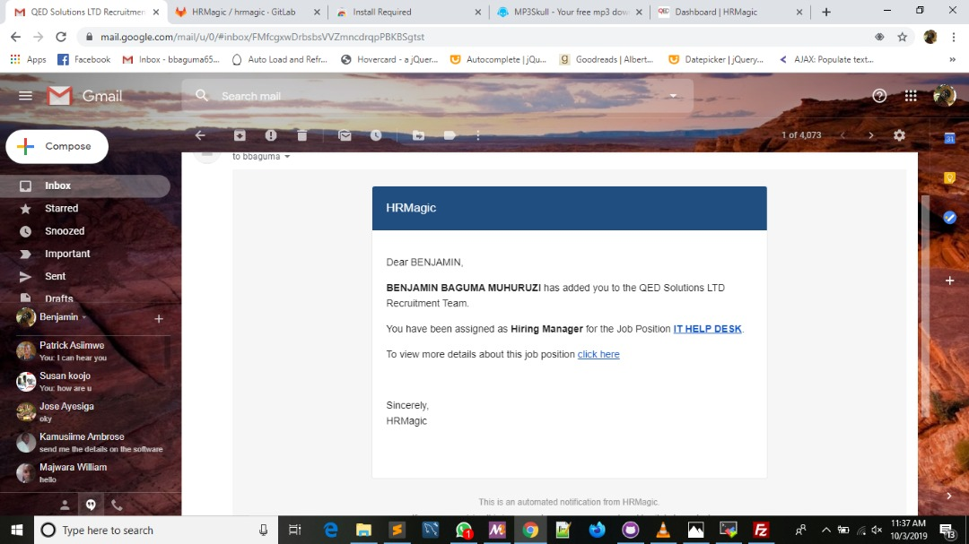

Figure 4: Email Notification

### Candidate Assessment

The HR uses this section to assess the application by setting up questions that the applicants will fill in as they are applying These questions can be simple text or drop down where a candidate has to select from a set of options. .

### Review Preferences & Publish

This is the final step of adding a new job. The Publish date and Expiry date of the Job advert are set from this tab. The HR can either save as draft or Publish Job. The job advert is published on the organization career page linked to HRMagic i.e. <http://url/careers> where by the URL represents the link to the domain being used for publishing the jobs.

## Candidates

This section displays all applicants in the recruitment module. It displays all applicants i.e. those with submitted, draft/incomplete applications with their registered details. The HR can filter using side the different options such as qualification, work experience, education and many more.

## Careers Page

To navigate to this section, go to **Module -> Recruitment -> Careers page (Published jobs).** This leads to the organization’s portal for careers as shown in the figure below. The jobs published under the New Job interface are displayed in this section.

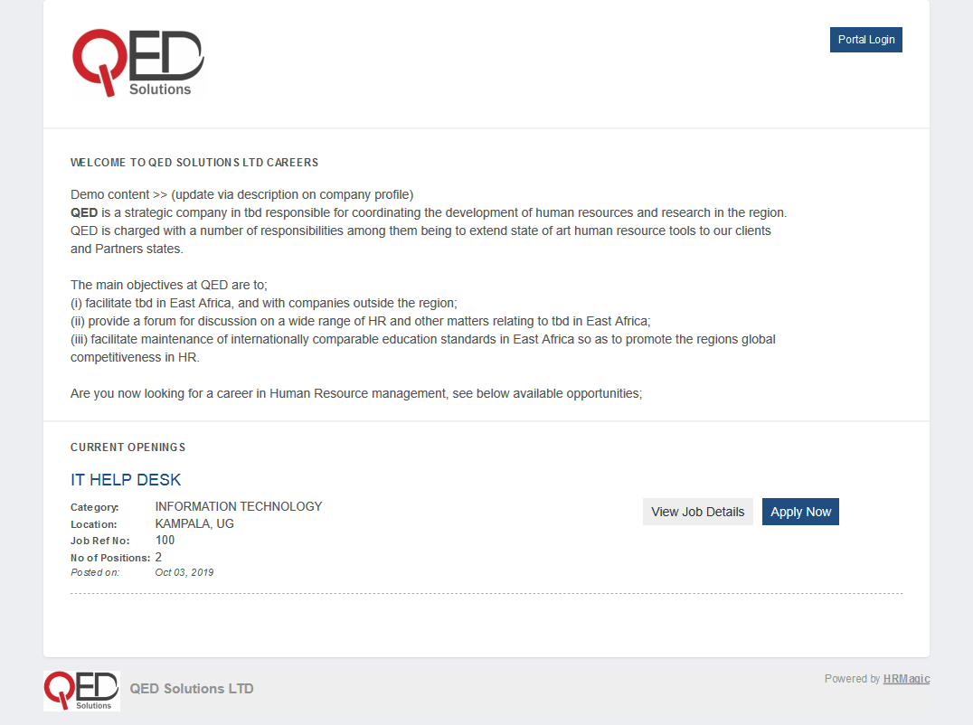

Figure 5: Careers page

The applicant can view the job details such as job specifications, requirements and more from the tab shown below.



The interested applicant can click on the Apply Now tab as shown below so as to proceed in the application process.



## Application Procedure

Once the job is published on the organization’s career page, an applicant can access this interface and apply for the advertised job. The figure below shows the steps of the application process from step 1 to step 5, each with the right information and submitted. We always emphasize that the applicant should prove the correct phone number and email address as those will be the primary means through which the recruiter will be able to reach them.

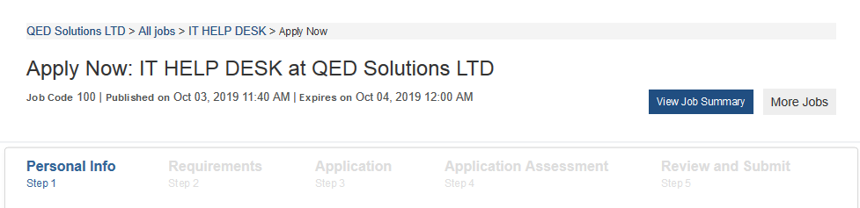

Figure 6: Application Steps

After submitting the application, an email confirming receipt of application is sent to the applicant as shown in the figure below.

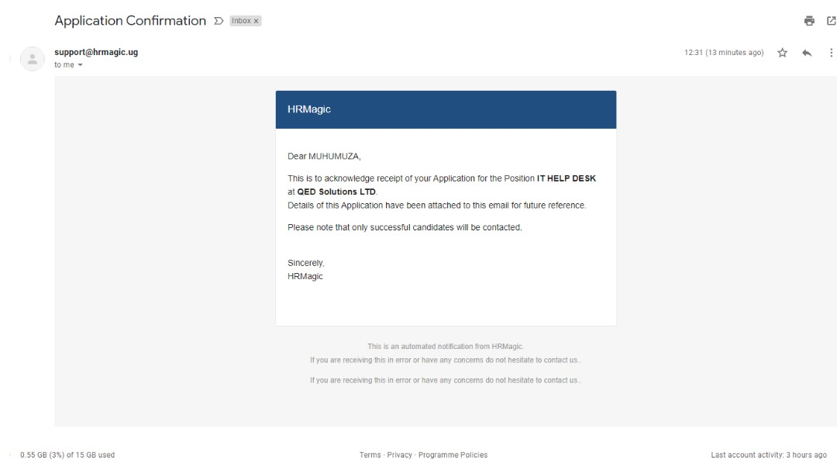

Figure 7: Receipt of Application Email

## The recruitment pipeline

This section shows from when the candidates submit their application till the qualified candidates are hired as shown in the figure below.

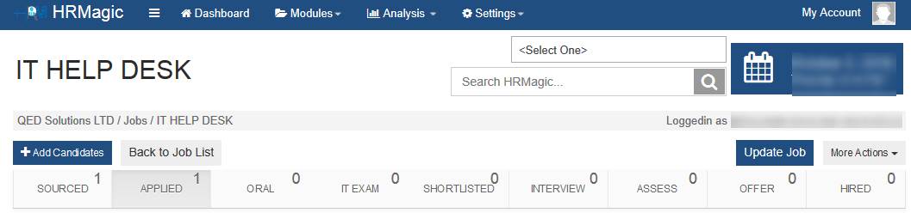

Figure 8: Recruitment pipeline

The recruitment process includes the following steps

1. Sourced
2. Applied
3. Oral
4. IT Exam
5. Shortlisted
6. Interview
7. Assess
8. Offer
9. Hired

These above mentioned steps are very important as they will assist the recruiter to be able to move applicants from one stage to another as long as they qualify.

The hiring team members can either disqualify or forward the candidate to the next step by clicking on the “Move To” tab as shown in the figure below

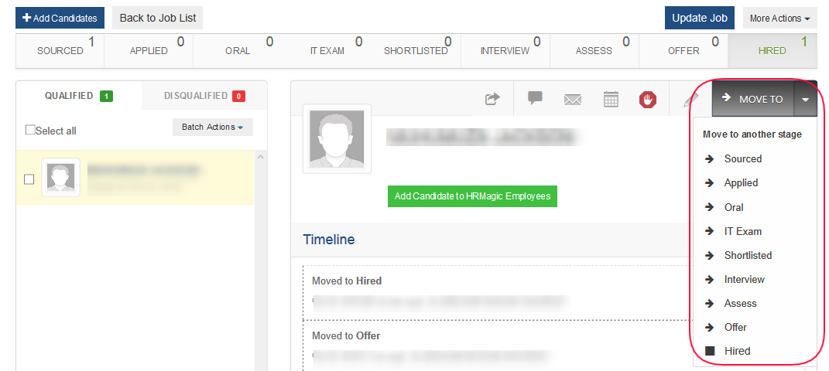

Figure : Move to another stage

The table below shows the tabs in the figure above and their meanings with regard to the candidate assessment.

|  |  |
| --- | --- |
| **TAB** | **MEANING** |
|  | Move/copy candidate |
|  | Add note to the candidate’s profile |
|  | Email a candidate |
|  | Schedule an event |
|  | Disqualify a candidate |
|  | Can edit the candidate profile |
|  | Update job, preview on careers, unpublish job and delete job |

**NOTE**

The Hired step is the final step of the candidate evaluation, where the only qualified candidates are sent job offer emails and added to the employee list of the organization as shown in the figure below.

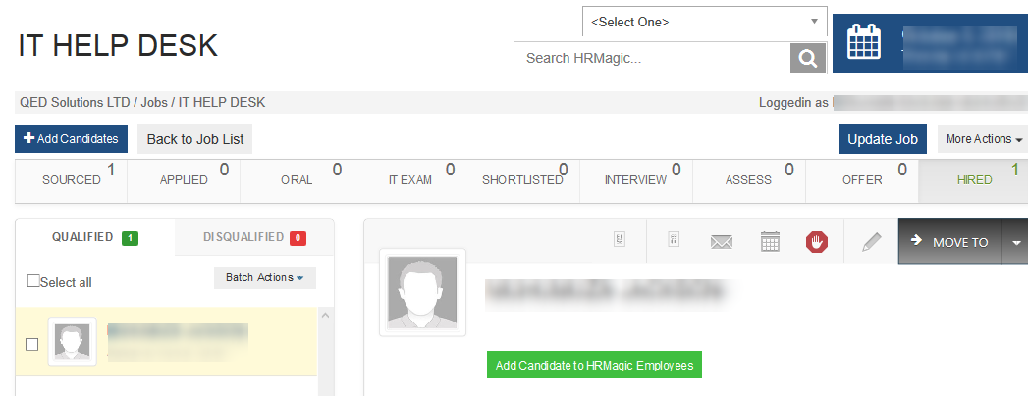

Figure 10: Hired step

## Report

### Recruitment Progress report

To navigate to this section, go to **Module -> Recruitment -> Recruitment Progress Report**. This section provides a summarized report of the recruitment progress.

To generate this report;

1. Select from the drop-down the job advertised
2. Select the analyze option. The analysis option has 4 parts such as; analyze by gender, experience level, age, and education level.
3. Click on the generate tab as shown in the figure below.

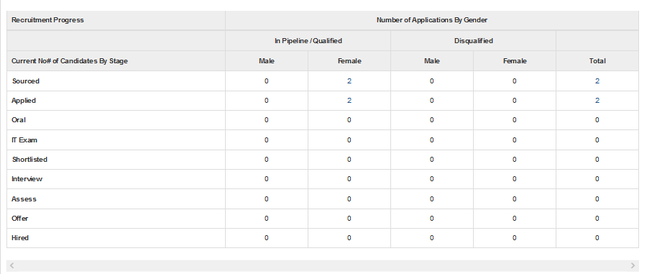

Figure 11: Recruitment Progress Report

### Candidates Biodata Report

This section shows all the bio-data details of applicants for a published job. To access this section, go to **Module ->** **Recruitment -> Candidates Biodata Report**. An employee with system rights/HR can filter and generate a report as shown below.

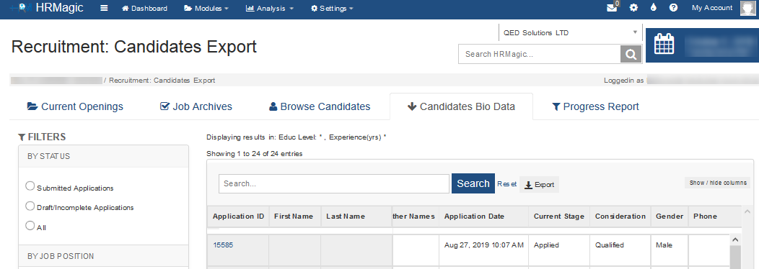

Figure 12: Candidates Bio Data Report